Branding Strategy & Communication Campaign Report: Chakh-Na
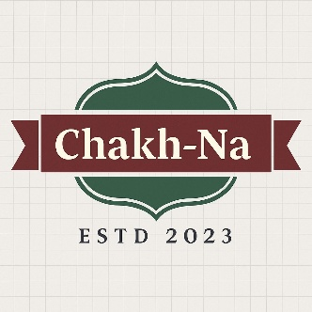

Website:- CHAKH-NA
Insta ID:- CHAKHNA
ADVERTISMENT

Index
- Introduction
- Pre-Launch Planning
  - Market Research & Consumer Insights
  - Product/Service Concept Development
  - Branding Strategy
- Launch Planning & Execution
  - Integrated Marketing Communication (IMC) Plan
  - Digital & Non-Digital Engagement
- Post-Launch Performance Tracking
  - Consumer Feedback & Monitoring
  - Performance Metrics & KPIs
  - Continuous Improvement & Scalability
- Budget Overview
- Conclusion
- References

1.Introduction
The healthy snack market is experiencing exponential growth due to a rising awareness of health and wellness among consumers. This project aims to develop a branding strategy and communication campaign for “Chakh na,” a new healthy snack brand offering products such as Amla candy, Coconut barfi, Makhana, Sundal, Thattai, and Gazzak. The goal is to address an unmet consumer need for tasty and nutritious snacks, while also ensuring the brand resonates with the target audience.
2. Pre-Launch Planning
2.1 Market Research & Consumer Insights
(a) Identify an unmet consumer need
Through secondary research and surveys, we identified a significant unmet consumer need for healthier snack options that do not compromise on taste. According to the “Health and Wellness Food Market – Growth, Trends, COVID-19 Impact, and Forecasts (2023 – 2028)” report from Mordor Intelligence, the health snack market is projected to grow at a CAGR of 6.4% from 2023 to 2028.
Survey Results:
- 65% of participants expressed a desire for snacks that are both healthy and convenient.
- 70% indicated that they are willing to pay a premium for organic ingredients.
- 80% expressed dissatisfaction with existing healthy snack options due to taste.
(b) Competitive Analysis
SWOT Analysis:
Strengths | Weaknesses
Unique product offerings | New entrant with limited brand recognition
Focus on healthy ingredients | High competition from established brands
Natural and organic certifications | Limited distribution channels

Opportunities | Threats
Growing health-conscious consumer base | Aggressive pricing strategies by competitors
Expansion into online retail | Economic downturn affecting consumer spending
PESTEL Analysis:
Political | Economic | Social | Technological | Environmental | Legal
Supportive policies for healthy eating | Rising disposable incomes | Increased health consciousness | Growth in e-commerce | Sustainability trends | Compliance with food safety standards
Porter’s Five Forces:
- Threat of New Entrants: Moderate
- Bargaining Power of Suppliers: Low
- Bargaining Power of Buyers: High
- Threat of Substitute Products: High
- Industry Rivalry: Very High
Define the Target Audience
Demographic Segmentation:
- Age: 18-45 years
- Income: Middle to upper-middle class
- Geography: Urban areas with health and wellness trends
Psychographic Segmentation:
- Health-conscious consumers who prioritize nutrition
- Trend-seekers looking for innovative snack options
Behavioral Segmentation:
- Snack consumers who prefer organic and natural ingredients
- Individuals engaged in fitness activities
2.2 Product/Service Concept Development
(a) Value Proposition & Unique Selling Proposition (USP)
Value Proposition: Chakh na provides healthy, flavorful snacks that cater to the growing demand for nutritious eating without sacrificing taste.
USP: “Deliciously Healthy Snacks for Every Occasion”
(b) Brand Personality Traits and Positioning Statement
Brand Personality Traits: Health-conscious, innovative, vibrant, and approachable.
Positioning Statement: “Chakh na is the go-to brand for health-conscious snackers who crave delicious, guilt-free indulgence.”
Product Features, Pricing Strategy, and Packaging Design
Product | Features | Price per Gram (Retail) | Packaging Design
Amla Candy | Rich in Vitamin C, low sugar | Rs. 99-129 | Eco-friendly pouch with vibrant graphics
Coconut Barfi | Gluten-free, organic ingredients | Rs. 119 -149 | Biodegradable box with clear window
Makhana | High in protein, no preservatives | Rs. 89-119 | Reusable jar with a modern design
Sundal | Packed with fiber, nutritious spices | Rs. 99 -129 | Kraft paper pouch with minimalistic design
Thattai | Traditional recipe, gluten-free | Rs. 99 -129 | Attractive resealable bag
Gazzak | High in energy, all-natural | Rs. 99-129 | Brightly colored box

3. Branding Strategy
3.1 Develop Brand Name, Logo, Tagline, and Visual Identity
- Brand Name: Chakh-Na
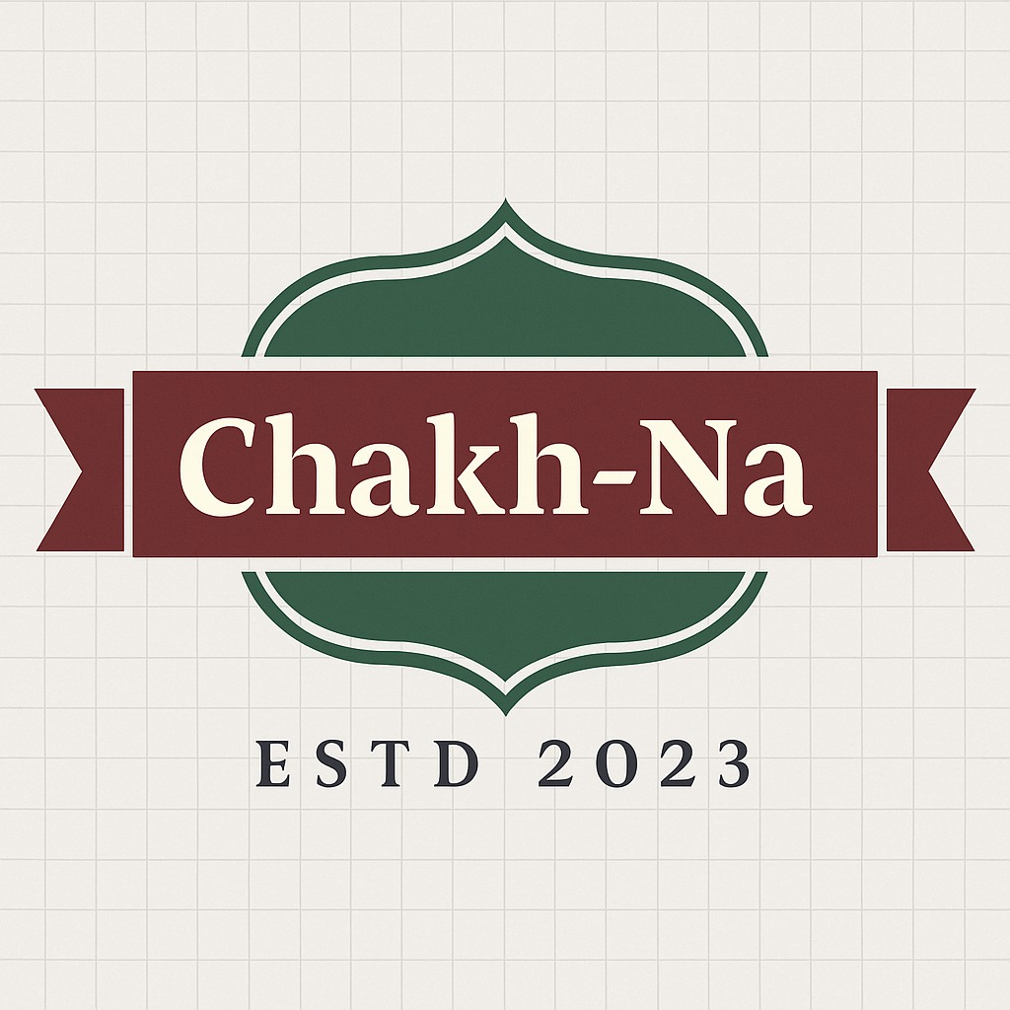
- Logo:

- Tagline: “Healthy Bites, Happy Hearts”
- Visual Identity: A color palette that combines green and orange, representing health and vitality.
3.2 Align Branding with Consumer Psychology and Market Trends
Our branding strategy will leverage the increasing trend of health-consciousness alongside the psychological appeal of natural ingredients. The brand will communicate a message of trust, authenticity, and taste.
3.3 Ensure Consistency in Brand Messaging Across All Channels
All branding efforts will consistently emphasize the core message of healthy indulgence across packaging, digital content, and advertising mediums.

4. Launch Planning & Execution
4.1 Integrated Marketing Communication (IMC) Plan
(a) Digital and Traditional Marketing Mix
- Digital Channels: Social media (Instagram, Facebook, TikTok), SEO, and influencer partnerships.
- Traditional Channels: Print ads in health magazines, local newspapers, and outdoor advertising like billboards.
Rationale for Selection: The target audience predominantly engages with digital media; however, traditional channels will enhance brand visibility in local markets.
(b) Key Marketing Messages and Storytelling Techniques
Key Marketing Messages:
- “Snack Smart with Chakh na”
- “Nature’s Goodness in Every Bite”
Storytelling Techniques: Use customer testimonials and behind-the-scenes stories focusing on ingredient sourcing and production methods.
Marketing Activity | Channel | Timeline | Budget Estimate ($)
Pre-launch teasers | Social Media | 2 weeks | 2,000
Launch day promotion | Influencer Marketing | Launch Day | 5,000
Ongoing engagement | Email Marketing | Ongoing | 1,500/month
Print Ads | Local Magazines | 1 month | 3,000
Outdoor Advertising | Billboards | 3 months | 10,000
Advertising Campaigns
- Social Media Ads: Targeted ads on Instagram and Facebook showcasing product benefits.
- Influencer Collaborations: Partner with health and wellness influencers for authentic promotion.
(d) Media Budget
Total Media Budget: $20,000 (including all advertising, influencer marketing, and engagement strategies).
Media Type | Budget ($)
Digital Marketing | 10,000
Traditional Advertising | 5,000
Influencer Marketing | 3,000
Public Relations | 2,000

Timeline for Campaign
Phase | Start Date | End Date
Pre-launch Teasers | March 1 | March 15
Launch Day Promotions | March 16 | March 16
Ongoing Engagement | March 17 | Ongoing

5. Digital & Non-Digital Engagement
5.1 Digital Platforms
- Website: A user-friendly e-commerce platform showcasing products and recipes.
- Social Media Marketing: Engaging content focused on health tips and recipes.
- Influencer Marketing: Collaborate with nutritionists and lifestyle influencers.
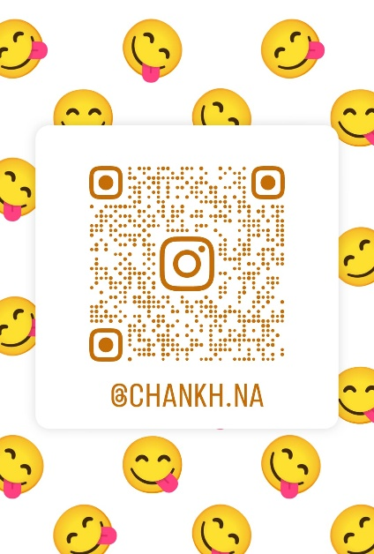
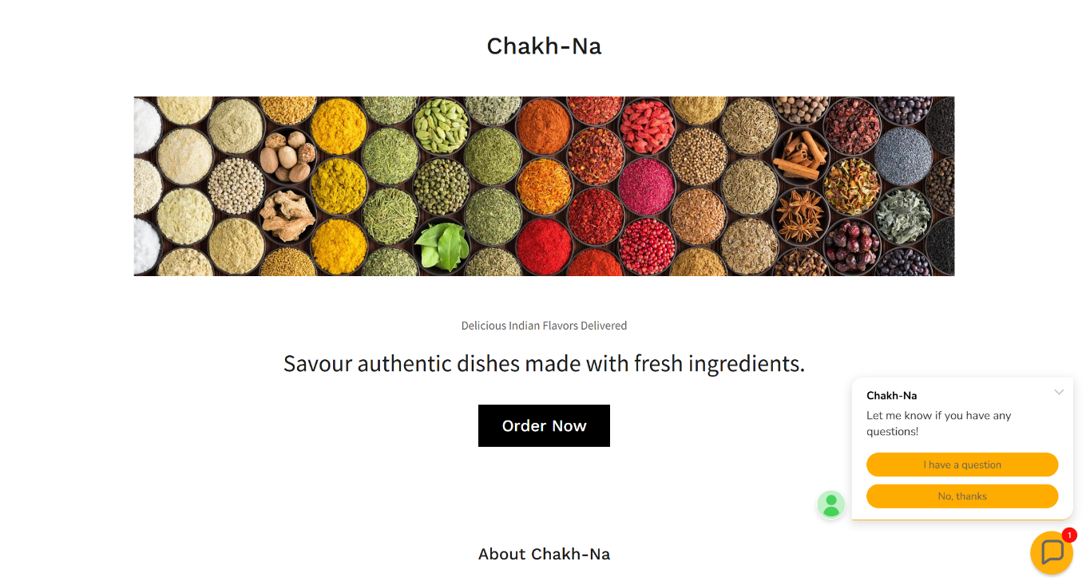
- SEO Strategies: Optimize content for keywords related to healthy snacks.
Company Website :- Chankh-Na

5.2 Non-Digital Engagement
- Public Relations: Send press releases to health journals and magazines.
- Events: Sponsor health fairs and community events to sample products.
- Outdoor Advertising: Billboards in strategic locations targeting health-conscious consumers.
5.3 Engagement Strategies
- Contests: Social media challenges encouraging users to share their healthy snack moments.
- Interactive Content: Polls and quizzes about favorite snacks and recipes.
- Referral Programs: Incentivizing customers to refer friends with discounts.

6. Post-Launch Performance Tracking
6.1 Consumer Feedback & Monitoring
(a) Feedback Collection Methodology
Methodology:
- Online Surveys: Post-purchase surveys sent via email.
- Social Media Listening: Monitor comments, shares, and mentions.
- Review Tracking: Analyze customer reviews on e-commerce platforms.
(b) Customer Sentiment Analysis Techniques
Qualitative Analysis: Thematic analysis of open-ended survey responses.
Quantitative Analysis: Sentiment scores generated by analyzing review data and social media mentions.
6.2 Performance Metrics & KPIs
- Sales Volume: Measure overall sales and product-specific sales.
- Customer Acquisition Cost (CAC): Total marketing spend divided by new customers acquired.
- Customer Lifetime Value (CLV): Average revenue generated from a customer over their relationship with the brand.
6.3 Continuous Improvement & Scalability
Long-term Sustainability Plans:
- Introduce new product lines based on consumer feedback.
- Explore subscription models for regular customers.
- Expand distribution channels into grocery stores and health food retailer

7. Budget Overview
Total Budget Allocation
Category | Budget ($)
Market Research | 3,000
Product Development | 5,000
Branding & Design | 4,000
Advertising & Promotion | 20,000
Operations & Logistics | 5,000
Total | 37,000
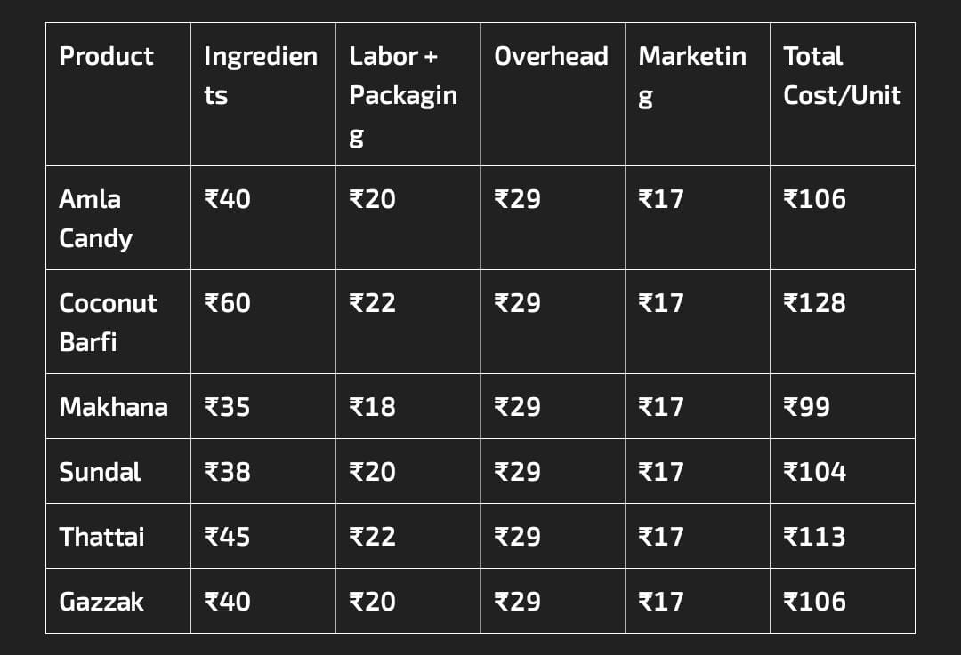

8. Conclusion
Chakh na is poised to become a significant player in the health snack market by addressing the existing gaps between taste and nutrition. The proposed branding strategy and communication campaign effectively leverage market trends and consumer insights to create a compelling brand identity.
With a detailed launch plan and robust performance tracking mechanisms in place, Chakh na can achieve sustainable growth and scalability in the competitive snack landscape.
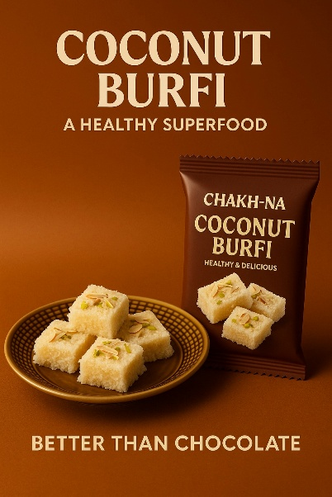
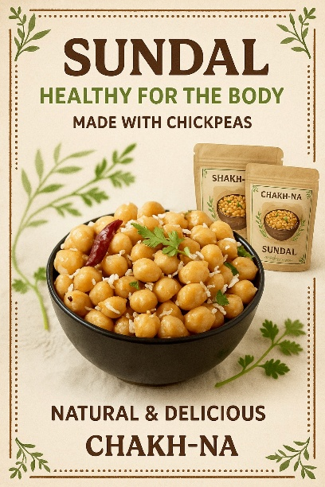
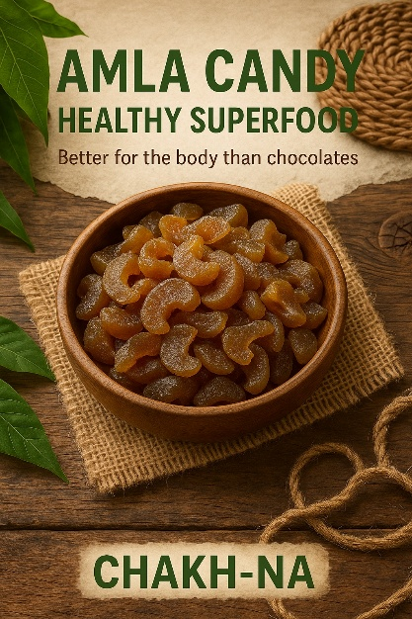

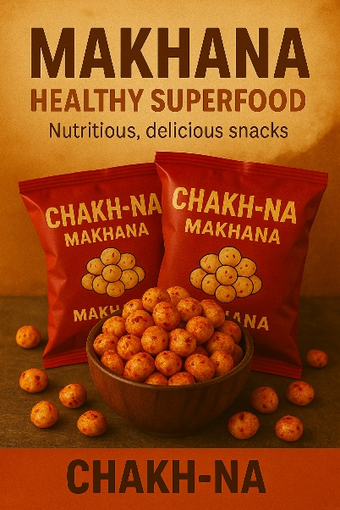
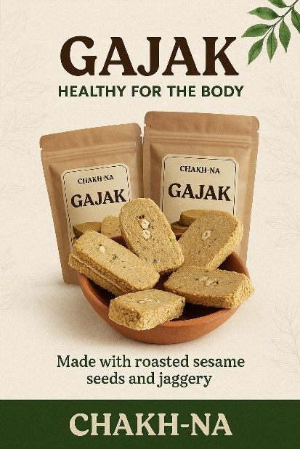
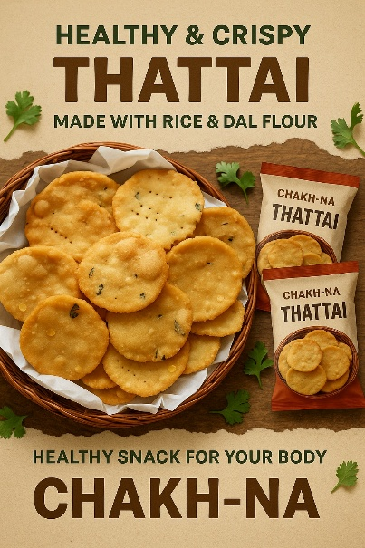

9. References
- Mordor Intelligence. (2023). Health and Wellness Food Market - Growth, Trends, COVID-19 Impact, and Forecasts (2023 - 2028).
- Statista. (2023). Revenue in the Healthy Snacks segment.
- Nielsen. (2023). Global Health and Wellness Trends.
- Euromonitor International. (2023). Snack Food in the World Market: Report and Analysis

